

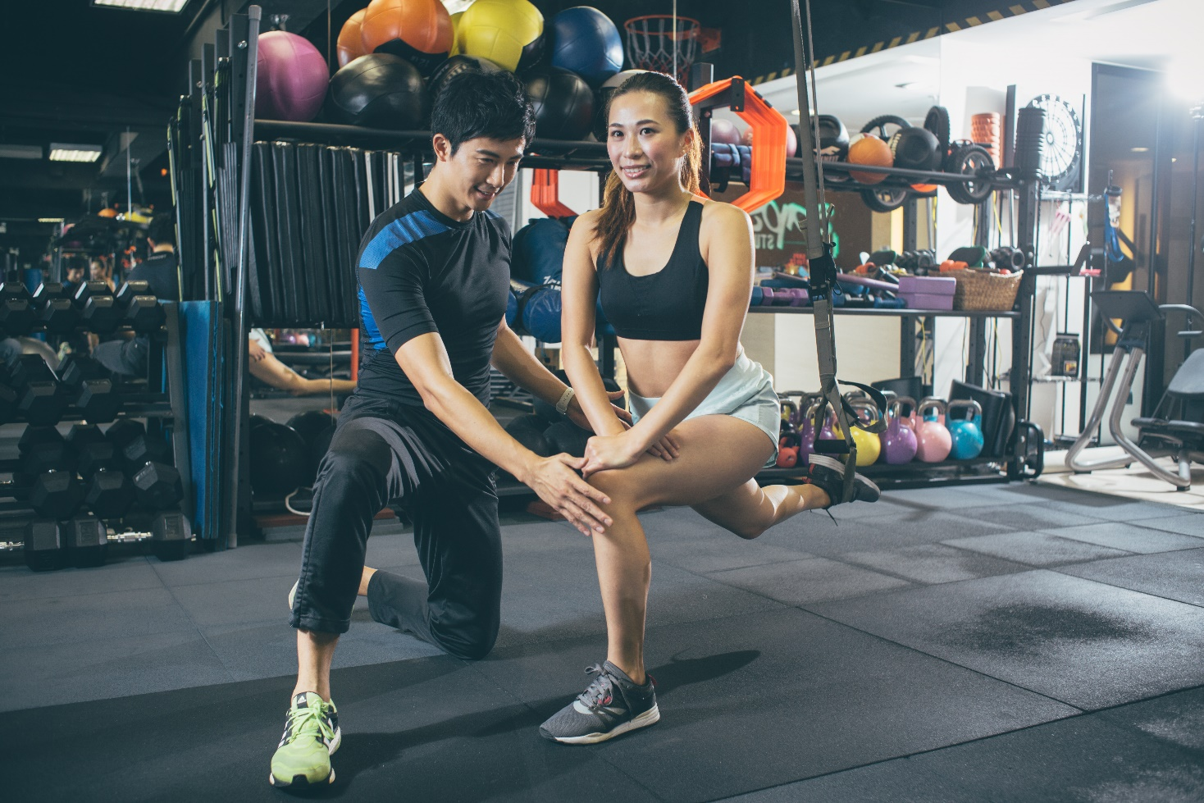

高級私人體適能教練證書
Certificate in Advanced Personal Fitness Trainer
15小時實習作業冊
15-Hour Practicum Programme Workbook
（內附評核表及實習證明書）

Student Name 學員姓名:_____________________________________
Club House / Fitness Centre 會所／健身中心:______________________________________
Course Code 課程編號:______________________________________
Contact No. 聯絡電話:_______________________________________
Submission date 繳交日期:____________________________________

www.aasfp.com

Contents
Page頁 Completed?
Introduction ……………………………………………3 ＿＿______＿

Chapter 1：Starting the fitness career
Task 1：Self-analysis……………………………………………….4-5 ＿＿______＿

Task 2：Career Path and Personal Development………………..5-6 ＿＿______＿

Task 3：Promote your own business……………………………....7 ＿＿______＿

Chapter 2：Client Prospecting and fitness goal review
Task 4：Clients Prospecting…………………………………….8-9 ____________

Task 5：Fitness goal review.............................................................10 ____________

Chapter 3：Personal Training Techniques
Task 6：Personal Training Technique………………………..11-12 ____________

Chapter 4：Final Project
Task 7：Final Project（Brochure or Video clip）…………13-14 ____________

Appendix
Internship reference letter………………………………………..16 ____________

Performance Assessment …………………………………….…17-18 ____________

Confirmation Letter…………………………………………….18 ____________

Item Checklist……………………………………………..…….19 ____________

────────────────────────Introduction
Being part of the Advanced Personal Fitness Trainer Course, working in the gym/club environment will provide fresh personal trainer graduates an opportunity to be familiar with the real working environment and the operation of the fitness centre. In the process of the internship program, you should aim at:
  - Learning and experiencing what is required in becoming a personal trainer
  - Understanding the possible career path and personal/business development opportunities in a commercial fitness center
  - Gaining knowledge and experience in how to get started as a personal trainer
  - Gaining experience in how to prospect and approaching gym users, both in person and by phone
  - Attaching an experienced personal trainer and observe how a PT session is conducted
To complete the internship programme, students must follow the instruction to finish all the tasks 1-7 in the internship workbook and have the ‘Evaluation form’ and ‘Confirmation Letter’ completed and signed by the fitness centre/club manager/supervisor. Finally, students must bear in mind the internship programme is a part of the training to be awarded the certificate. No payment will be paid for the internship programme.

Objectives
In the process of doing this workbook:
  - It helps review most of the aspects of the certification course in a practical setting
  - It helps related topics that you have learnt in the lecture to real life
  - It gives you the confidence and understanding of the responsibilities of a professional personal trainer

Usage Guide
      - To be familiar with the workbook content and the type of information before you start the programme
      - At the start of programme, hand in the reference letter and performance assessment form (p.19-22) to your supervisor and make sure he/she will arrange at least 1 hour to provide the information required
      - Ensure to take this workbook every time you attend the internship programme for completion of tasks
      - Let the questions and instruction in each section guide you to what has to be done
      - Should you require additional space, use separate sheet(s) of papers.
      - This workbook does not carry any mark; however, it can reflect your understanding of the course materials and your responsibilities of what it takes to be a professional personal trainer. Therefore, you must complete all the required tasks (1-7) before you can take the certification of the course.
      - The Internship Programme ‘Evaluation Form’ and ‘Confirmation Letter’ are included in this workbook. Please remember to complete them with appropriate authority (Signature of fitness/club manager or supervisor).
      - AASFP reserves the copyright and rights to change the contents.
      - Copyright materials reproduced herein are used under the copyright owner.

Chapter 1: Starting the fitness career (Tasks 1 to 3)
Learning Objective
After finishing this chapter, you should be able to:
- Realize your strengths and weaknesses
- Equip and prepare yourself for the fitness trainer career

TASK 1 : Self-analysis
Get yourself ready and know your strengths and weaknesses
The career path and avenues into fitness instruction or personal training vary in different trainers. The only means to expand your business is to equip yourself. Grade yourself 1-10 (10 is the highest) and write down your strengths and weaknesses in each of the following items and think of how you can improve each of them.

Score
A. Knowledge: ＿＿＿＿＿＿
B. Experience: ＿＿＿＿＿＿
C. Communication and Presentation: ＿＿＿＿＿＿
D. Service and attitude: ＿＿＿＿＿＿
E. Skills and Techniques: ＿＿＿＿＿＿
1.1 How would you plan to improve the above item？
Knowledge | Strength:  Weakness:  Improvement:
Experience | Strength:  Weakness:  Improvement:
Communication and Presentation | Strength:  Weakness:  Improvement:
Service and attitude | Strength:  Weakness:  Improvement:
Skills and Techniques | Strength:  Weakness:  Improvement:

TASK 2 : Career Path and Personal development
Formulate your career path and personal development by prioritizing 6 specializations below and use approximate 100 words to describe why you would like to study further that specialization.

Medical Related：
- Posture Enhancement & Recovery Specialization/ Rehab Training Specialization/ Special Population Specialization
Fitness Related：
- Martial Arts Specialization/ Core, Muscle Conditioning & Functional Training Specialization/ Performance Enhancement Specialization

Example：
The sequence of interested specializations：
- Rehab Training Specialization－＞Special Population Specialization－＞Performance Enhancement Specialization－＞…etc
Rationale (such as market needs)：
- Office workers cause muscle overuse due to bad posture. If the neck and back overuse become chronic pain, it may affect the quality of life. In addition to the constant use of electronic devices, desk workers who suffer neck pain and back pain will gradually increase. Therefore, Rehab Training Specialization is an important part for the general public.
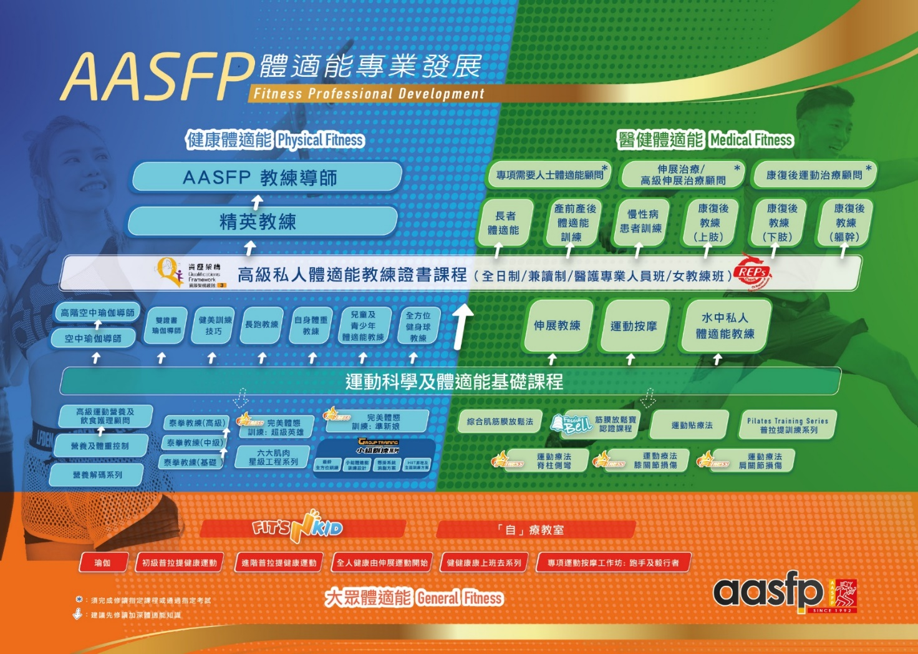
2.1 How do you formulate your career and personal development？
The sequence of interested specializations：

Rationale (such as market needs)：

TASK 3 : Promote your own business
Design your own business card in the following space. It can be a good template for you in the future. Your design MUST AT LEAST include the following (else you need to redo the task):
- Logo designed for yourself
- Name and contacts (telephone and email are the musts)
- Trainer certification and certified by which organization
- Others related qualifications
Or
If there is a social platform such as Facebook or Instagram, you are currently using to promote your business. You may screencap your account profile and provide the website in the following space.

3.1

Chapter 2: Client prospecting and fitness goal review (Tasks 4 to 5)
Learning Objective
After finishing this chapter, you should be able to:
- Understand the procedures and techniques of client prospecting for Personal Trainer
- Realize how the marketing techniques and communication skills can help the client prospecting
- Understand the procedures and techniques in Fitness Goal Review process
- Realize how Fitness Goal Review can help the trainer and client

TASK 4 : Client Prospecting
Observe how trainers of the gym/fitness center/club approach potential clients. Note and observe what did the trainer do during the process.

4.1. Write down the procedure of client prospecting. How does the Personal Trainer approach a potential client? (You can use a separate sheet of paper)
4.2. What is the information that must be collected during the prospecting procedure? (You can use a separate sheet of paper)
4.3. What types of marketing techniques or communication skills are used during the process? For example, the trainer impressed the client by answering his question on building a strong arm. (You can use a separate sheet of paper)

TASK 5 : Fitness Goal Review
Observe how trainers of the gym/fitness center/club carry out the fitness goal review or fitness assessment for the clients or potential clients. Note and observe what did the trainer do during the process.

5.1 Please describe the procedure of the client Fitness Goal Review and assessment. Any machines or tools are used? (You can use a separate sheet of paper)
5.2 What fitness component(s) is/are assessed during the procedure? (Please note that the result must be relevant to the Fitness Assessment)
5.3 Please explain how the client’s Fitness Goal Review helps the Personal Trainer and client based on your observation. (You can use a separate sheet of paper)

Chapter 3: Personal Training Techniques (Tasks 6)
Learning Objective
After finishing this chapter, you should be able to:
- Prepare a personal training session so that it can be run smoothly
- Understand how a personal training session is constructed and delivered
- Review a personal training session and improve the training skills

TASK 6 : Personal Training Techniques
Attach to a trainer and observe how trainers of the gym/fitness center/club to carry out the personal training session. Note and observe what the trainers do before and during the session.

6.1. What is/are the short term and long term training goal(s) of the client in the training process?
Types of clients: Fat burn/ Hypertrophy/ Rehab/ Sports Enhancement

Short-term goal:

Long-term goal:

6.2. Write down the content of one of the training sessions. It must at least have 3 parts: warm-up, training, cool down. For resistance training, it must contain exercises, weight, repetitions, sets, the resting time between sets. (You can use a separate sheet of paper)
6.3. What the communication skill(s) the Personal Trainer used to lead the client during exercises according to your observation? For example, how the Personal Trainer motivates the client to be more involved during the exercise. (You can use a separate sheet of paper)

6.4. After observation, how do you think the training session can be improved and learnt? If the client mentioned at 6.1 is your client, how do you set short-, mid- & long-term goal for your client to achieve a better training experience and effectiveness. What are the training programs and services would you provide accordingly?

Chapter 4: Final Project (Tasks 7)
Learning Objective
After finishing this chapter, you should be able to:
- Understand the importance of communication skills, including brochure, video clips etc.
- Make a brochure or video clip for educating clients or promotion of the fitness center

Final Project
Besides training skills, communication skills both in verbal and non-verbal, are also critical for a successful Personal Trainer. In the fitness center, Personal Trainers are also required to write up a proper brochure to introduce the exercises skills, health and fitness concepts or even sports injuries to clients. Nowadays, Personal Trainers may also be required to make a short video to promote your fitness center or yourself.
Please pick up ONE only of the following topics and complete the project according to our guidelines and submitted together with this workbook.

7.1. Making a brochure about one of the following subjects, so that you can put it in the fitness center and clients can be educated about the topic through reading it.
- 3 exercises to enhance sports performance (Basketball/ Distance Running/ Badminton) or
- 3 exercises to improve musculoskeletal pain for sedentary lifestyle or
- 3 exercises to build up your 6 pack abs (including Rectus Abs, Transverse Abs, External and Internal Obliques ) or
- 3 exercises to improve shoulder tendinitis

Your submitted brochure will be REJECTED and need to be redone if any one of the followings is missed or not followed:
- The submitted brochure must be in A4 size with COLOR printed copy (soft copy is not accepted)
- You MUST include 150 words with photo(s) to brief the cause of the problem or the training principles
- Introduce at least 3 resistance exercises that can help to improve the situation
- You must have photos and words to describe and explain the resistance training that can help to improve the situation
- For each training employed, you must follow the table below to describe the start/end position, body position and stability, adjustment of the machine if any, movement range and path, breathing, safety and how to change the difficulties
- You MUST put your credential, name and photo at the end of the brochure as author information
- NO handwriting is allowed
Selected exercise training flow
Name of exercise
Targeted muscle
Body position
Stabilization
Path of motion
Range of motion
Breathing
Rhythm
Sets and reps
Variations
Common mistakes

OR

7.2. Making a 3 minutes video clip about ONE of the following subjects through role play:
a) Explain to a client if the client asked, “Why I gain weight in conducting the fat burning program?”. OR
b) Explain to a client if the client asked, “If there is a cracking sound over the training area without pain, shall I keep doing it? OR
c) If my female client is looking for body shaping without significant muscle hypertrophy, what should I do? OR
d) If my left arm is much smaller than my right arm, what should I do? OR
e) Can I lose fat and gain muscle at the same time? If yes, how?

Your submitted video will be REJECTED and need to be redone if any one of the followings is missed or not followed:
- Your video clip format must be able to be opened and played by Window Media Player v11 or below (AVI and MPEG files)
- You must introduce yourself: name and personal credential
- You must clearly state the topic you selected at the beginning of the video before the role play
- Decent background must be required. No home, stair, or improper background
- The image/sound must be clear and can be heard and recognized.
- Proper dressing code is required
參考文獻
AASFP Advanced Personal Fitness Trainer Textbook 2016

AASFP Anatomy Flash Card. 4th ed. AASFP, 2016

Ann. L. Gibson & Vivian H. Heyward 2014 Advanced Fitness Assessment and Exercise Prescription 7th Edition, Human Kinetics

Bates, M. (2008). Health Fitness Management – A Comprehensive Resource for Managing and Operating Programs and Facilities, Human Kinetics

Brook, D. (2004). The Complete Book of Personal Training. Human Kinetics

Gregory. H & Travis. T. 2016 Essentials of strength training and conditioning, 4th Edition. NSCA

Griffin J.C., 2015, Client-Centered Exercise Prescription 3rd Edition, Champaign : IL, Human Kinetics

NASM 2004 Certified Personal Trainer – Optimum Performance Training for the health and Fitness Professional 2nd Edition, Human Kinetics



Internship reference Letter 實習介紹信
To Fitness center manager,

Thank you for arranging internship chance for our students. Please arrange at least 1 hour from the internship hours to help students to collect the following information about your fitness center/club so that the student can complete their workbook:
- The career development path of the trainer
- The prospecting process of Personal Trainer
- The fitness goal review assessment process of Personal Trainer
- The personal training session process
健身中心主管:

感謝您安排實習機會給予我們學員，為幫助學員完成實習目的及作業，請您於十五小時實習中，安排至少一個小時給予學員有關貴 中心以下資料：
- 教練的事業發展路線圖
- 私人教練如何拓展客戶
- 教練如何進行體適能評估
- 教練如何進行課堂，如之前有什麼準備、進行程序等

Asian Academy for Sports & Fitness Professionals
亞洲運動及體適能專業學院上

Assessment Table評核表: (Filled by Fitness / Club manager or supervisor 交由健身室 / 會所經理或負責人填寫)
Performance Assessment 表現評核
Please rate each of the following items accordingly and in the next page calculate the total score for each category (Professionalism, Communication and Programme Design) and the final result
請根據學員各項表現於下列各項給予評分，並在下一頁計出每方面的總分 (專業，溝通及運動方案設計)以及最後得分。
Score Calculation分數計算:
Assessment Item 評核項目 | Score 評分
Assessment Item 評核項目 | Bad  差 |  | Fair 一般 |  | Good  好
Assessment Item 評核項目 | 0-2 | 3-4 | 5-6 | 7-8 | 9-10
PROFESSIONALISM 專業 (40 points 分)
Teaching Methods– were they able to demonstrate confidently  Motivation Skills – did they encourage & motivate members  指導技巧 – 有信心地提供正確的示範  推動技巧 – 適當地鼓勵會員 | /10
Dress/ Appearance – was it of a professional standard  Punctuality – were they always on scheduled time  服裝/外觀 - 符合專業形像  守時 - 經常依時到達 | /10
Able to provide enough fitness / health knowledge to members and also use professional tone / wording to coach professionally  有足夠體適能及健康知識提供會員以及能夠運用專業措詞及語調教授 | /10
Did the trainer demonstrate consideration to safety  考慮到安全問題 | /10
COMMUNICATION SKILLS 溝通技巧 (30 points 分)
Introduction of the facility to new members  Introduction of themselves to the club’s members  Introduction of alternative training equipment to members  向新會員介紹場內的設施  向會員介紹自已  向會員介紹不同類別之訓練器材以供會員多個選擇 | /10
Open communication with the fitness/club manager/supervisor  Build up a friendly and nice image to members  保持與健身中心/會所之管理人員良好的溝通  建立親切及友善的形象予會員 | /10
Good application of verbal & non-verbal communication and members had positive feedback on their coaching  學員能善用講解及非口語之溝通技巧，以及會員對學員的講解及教授給予正面的反應 | /10
PROGRAMME DESIGN (For members or in form of case study)
運動方案設計 (以會員或個案研究的形式) (30 points分)
Chose suitable cardiovascular equipment to client with reasonable frequency, intensity, time and progression  選擇合適之心肺功能訓練器材予客人並且有合理的訓練長度、次數、強度及進程 | /10
Chose suitable resistance training equipment to client with reasonable frequency, intensity, time and progression  選擇合適之阻力訓練器材予客人並且有合理的訓練長度、次數、強度及進程 | /10
Chose suitable flexibility trainings to client with reasonable frequency, intensity, time and progression  選擇合適之柔韌性訓練予客人，並且有合理的訓練長度、次數、強度及進程 | /10

Please fill in the items below according to the above table將根據上表填寫以下細項
Category類別 | Score 得分 | Comments on each Category評語
Professionalism專業 | / 40
Communication溝通技巧 | / 30
Programme Design運動方案設計 | / 30
Total Score 總得分* | / 100
*如學員未能獲得60分或以上的評分，則被認為是不合格。學員需要重新安排15小時實習
If student unable to get 60 score or above would be considered as fail in the practical module. Student may have to rearrange the 15-hour internship.
Signature of Assessor 評核者之簽署: ______________________________ Date 日期:__________________
Name and Position姓名及職位_________________________________________________________________ *************************************************************
“CONFIRMATION LETTER證明書”
(Filled by Fitness / Club manager or supervisor 交由健身室 / 會所經理或負責人填寫)

DATE日期： ______________ _____________________________________________

NAME OF FACILITY公司名稱: ______________________________________________

TELEPHONE 電話: ______________________________________________

ADDRESS OF FACILITY公司地址: _______________________________________________________________

_______________________________________________________________

Dear Program Director of AASFP,

I am writing to confirm that ____________________________________________ has successfully completed the AASFP ADVANCED PERSONAL FITNESS TRAINER CERTIFICATION COURSE module C 15-hour Internship Programme, He/she commenced the programme on ________________ and completed the 15 hours by the ____________________.

Kindest Regards,

致亞洲運動及體適能專業學院課程總監：

本人特此證明學員_____________________________________________成功完成亞洲運動及體適能專業學院AASFP私人體適能教練實習訓練15小時。他/她由_______________________開始，至______________________完成15小時實習訓練。

謹致問候

________________________________ ________________________________
Signature簽署 Company Chop公司蓋印

________________________________________ ________________________________
Name and position 姓名及職位 Date日期

Checklist of Item Submission
Item Checklist 項目清單
(you MUST read this and check your work before submitting your work book)

You are required to submit the following items within A 3 MONTH period as from the date of your final examination For any question please contact 2578 9877 or via email: aasfp@aasfp.com.

- A copy of a VALID Cardiopulmonary Resuscitation (CPR) Certificate (at least 3 months)
- Evaluation Form - completed and signed by the Fitness Centre/Club Manager/Supervisor with company chop (page 17-18)
- Confirmation Letter - completed and signed by the Fitness Centre/Club Manager/Supervisor with company chop (page 18)
- Completed TRAINER Internship Programme Work Book (printed hardcopy WITH all 7 tasks completed) (page 4-14)
- For task 3, you MUST include the following information, otherwise, your workbook may be rejected:
- Logo designed for your self
- Name and contacts (telephone and email are the must)
- Trainer certification and certified by which organization
- Others qualifications
- The final project of task 7 – either brochure or Video clip (printed hardcopy for brochure, USB for video clip )
For brochure, please make sure your work follows the following guidelines, else it may be rejected:
- NO hand writing is allowed
- The submitted brochure must be in A4 size with COLOR printed copy (soft copy is not accepted)
- You must have photos and words to describe and explain the resistance training in provided format that can help to improve the situation
- You MUST put your credential, name and photo at the end of the brochure as author information

